CHAPTER ONE
INTRODUCTION
1.1 BACKGROUND OF STUDY
Following the increase world demand for energy accompanied by less potential hydrocarbon discovery in every tent exploration, present producing oil wells need proper attention during production for effective management and efficient production schedule in other to accommodate the peaking world energy demand. In view of this, over the years, artificial lift production method has played a vital role in assisting dead wells, liquid loaded wells and non- flowing oil wells to restore their production state. Artificial lift is used when reservoirs do not have enough energy to naturally produce oil to the surface or at the desired economic rate. It refers to the use of artificial means to increase the flow of liquids such as crude oil or water from a production well. The basic concept of artificial life is to add energy to the fluid column in a well bore in order to create a predetermined bottom hole pressure so the reservoir may produce the objective flow rate (Kermit, 1982). Artificial lift is used for two purposes: to induce flow in naturally dead wells and, more commonly, increase/maintain flow rate in already producing wells. As artificial lift can start, accelerate and increase recovery from a reservoir, it is widely used. By 2004 more than 90% of producing oil wells needed some form of artificial lift to reach the desired performance.
Depending on the fluid properties and well geometry there are several ways to artificially lift the production stream from an oil well. The most commonly used artificial lift systems are:
- Sucker rod (beam) pumps.
- Electrical submersible pumps.
- Gas Lift.
- Progressive cavity pumps.
- Hydraulic piston pumps.
- Hydraulic jet pumps.
The electrical Submersible Pump (ESP) is today the second most used artificial lift device with over 100,000 operating pumps worldwide. The ESP system consists of a multistage centrifugal pump, an electrical motor, a motor controller, power cables, a topside power unit and some sort of gas separation component. The ESP is fully submerged and placed at a chosen depth in the wellbore. Power is transmitted to the motor through electrical cables fastened to the outside of the tubing.
The ESP performance is described in characteristic pump performances plots. These plots show the relationship between the pressure rise (head) and flow rate through the pump, the horsepower requirements and the pump efficiency, all for a certain rotational speed. The plots are created by the pump manufacturer based on tests with water as test fluid. Usually for a multistage pump only one pump stage is displayed in such a plot. Generally, this is achieved by the use of a mechanical device inside the well (known as pump or velocity string) or by decreasing the weight of the hydrostatic column by injecting gas into the liquid some distance down the well. More than 90% of producing oil wells require some form of artificial lift. The electrical submersible pump (ESP) was introduced as an artificial lift system in 1927. Today ESPs are the second most common artificial lift method, with over 100,000 pumps operating globally.
The ESP consists of a centrifugal pump mounted on an electrical motor. Centrifugal pumps are dynamic devices that use kinetic energy to increase fluid pressure. The centrifugal pumps used in ESP applications are mostly multistage pumps with small diameters and many stages. This design makes them fit inside small wellbores, still being able to deliver high pressure increments. ESPs are successful when handling liquids, ranging from low to medium viscosities. Their performance is characterized by the relationship between the pressure increment over the pump and the flow rate through the pump, for a certain rotational speed. This relationship is usually shown in characteristic pump performance curve plots. The performance curves are based on tests done by pump manufacturers using water as test fluid.
Similarly, the sucker-rod or Beam pumping lift method remained the oldest and most widely used type of artificial lift for most wells. A sucker-rod pumping system is made up of several components, some of which operate aboveground and other parts of which operate underground, down in the well. The surface-pumping unit, which drives the underground pump, consists of a prime mover (usually an electric motor) and, normally, a beam fixed to a pivotal post. The post is called a Sampson post, and the beam is normally called a walking beam Zaba (1943). Fig.1.1 presents detailed schematics of a typical beam-pump installation.
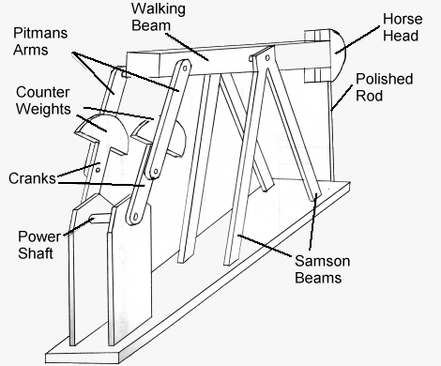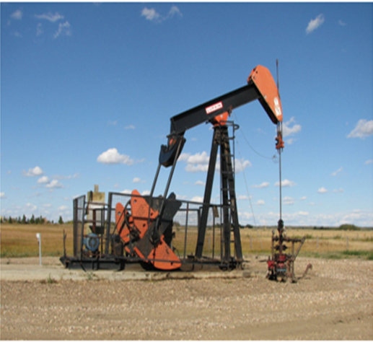
Fig. 1.1: Components of a Sucker-rod Pump
This system allows the beam to rock back and forth, moving the downhole components up and down in the process. The entire surface system is run by a prime mover, V-belt drives, and a gearbox with a crank mechanism on it. When this type of system is used, it is usually called a beam-pump installation. However, other types of surface-pumping units can be used, including hydraulically actuated units (with and without some type of counterbalancing system), or even tall-tower systems that use a chain or belt to allow long strokes and slow pumping speeds. The more-generic name of sucker-rod lift, or sucker-rod pumping, should be used to refer to all types of reciprocating rod-lift methods.
Linked rods attached to an underground pump are connected to the surface unit. The linked rods are normally called sucker rods and are usually long steel rods, from 5/8 to more than 1 or 1 1/4 in. in diameter. The steel rods are normally screwed together in 25- or 30-ft lengths; however, rods could be welded into one piece that would become a continuous length from the surface to the downhole pump. The steel sucker rods typically fit inside the tubing and are stroked up and down by the surface-pumping unit. This activates the downhole, positive-displacement pump at the bottom of the well. Each time the rods and pumps are stroked, a volume of produced fluid is lifted through the sucker-rod tubing annulus and discharged at the surface.
1.2 STATEMENT OF PROBLEM
One of the challenges facing the oil and gas industry is to produce the well to the surface on natural drives mechanism as long as possible before the need for assisted flow system. In practice, the reverse is the case, lifting of oil well with artificial method to the surface has come to stay as a culture of producing oil well at the early stage in well with heavy water cut or later stage in aging wells as a result of production decline due to pressure drop. This decline may result from mismanagement of wells, liquid loading, water conning, excessive pressure drops along the production system, oversized or undersized tubing, choke and improper selection of the right lifting method in reference to the type, depth and other associated problems. In view of this, there is need for technical decision on the right artificial method through an effective comparison using oil wells production engineering data for selection. Hence, this project intend to compare the performance of electrical submersible pump and sucker rod pumping lift system through the design and simulation of oil well production data on a software.
1.3 OBJECTIVES OF STUDY
- To evaluate the needs and the performance of sucker rod and ESP lifting systems.
- To simulate for the case of sucker rod and ESP lifting performance using oil well production data.
- To compare the simulation results of both lifting system and select the best option for lifting oil wells in the oil province considered.

1.4 SIGNIFICANCE OF THE STUDY
This work will be highly significant to the oil and gas operators, as well as the production engineers, especially those operating in the Niger Delta region where issues like water breakthrough leads to early liquid loading which in-turn affects production rate followed by a decline in the oil flow rate and adverse economic in return.
1.5 SCOPE AND LIMITATIONS OF THE STUDY
The scope of this project is to conduct a comparative study of the performance sucker rod and ESP lifting system on a producing oil well data in the Niger Delta using a prosper software for the design and simulation.

CHAPTER TWO
2.0 LITERATURE REVIEW
The increasing use of artificial lift in the petroleum industry has resulted in a lot of documentation on the field. The reasons to use artificial lift. And the benefits of using it are well covered by technical papers. Various articles are also written on each of the different artificial lift systems, making it easy to find general information about ESP operations.

2.1 ESP PERFORMANCE UNDER TWO-PHASE FLOW CONDITIONS.
Before the petroleum industry became interested in the effect of gas on ESP performance, very few studies were carried out on this topic. Although the nuclear industry had conducted several experiments on the effect of free gas on centrifugal pump performance, the models they had developed could not be used to predict ESP performance for the corresponding flow conditions. This was due to significant difference in pump design, usually single stage pumps with large diameter. The petroleum industry started to perform their own experiments more than twenty years ago, and several studies have been carried out since then. These studies have been fundamental to understand the basic effects and trends regarding ESP performance under two-phase flow conditions. Recent studies have also been important to derive theoretical models and correlations to predict ESP performance and behavior when handling two-phase flow. Some of the most important works done by the petroleum industry will be presented in the next paragraphs.
Lea and Bearden (1982) were among the first to perform laboratory testing of ESP performance under gassy conditions. Their research has been fundamental for understanding the basics, and essential for further studies done on the topic. They conducted two different tests. The first test used air and water as working fluids. A multistage centrifugal pump containing five Centrilift 1-42 stages were used in the experiment. The gas fractions were varied from 0 to 17%, and the intake pressures from 25 to 30 psig. The second test used CO₂ and diesel as working fluids. Three different pump types were tested. The first of them was an eight-stage 1-42 pump, the same as used in the air-water test. It was tested with gas fraction ranging from 0 to 40%, and with intake pressure at 50, 100 and 400 psig. The two other pumps tested were a C-72 radial pump and a K-80 mixed flow pump, with optimal flow rate of 72 and 80 gal/min respectively. These two last pumps provided a comparison of two different designs with the approximate same design rate. These pumps were tested with 10 and 15% free gas, at intake pressure of 50, 100 and 200 psig.
The work of Lea and Bearden was essentially experimental, and no models to account for the observations were presented. They concluded that there exist critical limits of free gas, at which the pump performance is severely reduced. Further they conclude that the pump performance under two-phase conditions is somewhat affected by both intake pressure and pump design.
Sachdeva (1989) presented the first two-phase model for ESP radial stages developed by the petroleum industry. This model was based on the two-phase models made by the nuclear industry, adapted to fit the multistage pumps used in ESP installations. The model was calibrated with data from the Lea and Bearden experiments.
To include axial design in the model it was extended three years later by Sachdeva et al. (1992). Through the next years several experiments and analysis were executed. And a few theoretical models were developed. Unfortunately, further testing showed that these models were valid only for pumps with the same number of stages as the pump used to obtain the data from which the models were made.
Pessoa and Prado (2003) introduced a new way to perform two-phase tests on multistage pumps to solve the model validity problem. Rather than measuring the pressure increment over the pump, the pressure increment was measured over each stage. The experiment was conducted at facility provided by Tulsa University Artificial Lift Projects (TUALP).
A 22-stage centrifugal pump (GC 6100,513 Series) was used in the experiment. Air and water were used as working fluids, and the pump intake pressure was kept constant at 100 psig. The test procedure consisted of varying the liquid flow rate for a constant gas rate. Then increase the gas rate and repeat the experiment. Liquid flow rates from 900 to 8,200 B/D and gas flow rates from 5,000 to 39,000 scf/d were used.
All tests were done at a constant pump speed of 3,208 RPM (55 HZ). This was the first time stage-wise two-phase performances were evaluated and presented. Pessoa concluded that the average performance of the pump is significantly different from that observed for each stage. He also concluded that current knowledge was not sufficient to develop a general and accurate model for predicting head degradation, gas locking and surging conditions.
Beltur (2003) performed a new two-phase experiment with the 22- stage pump used by Pessoa in 2000. Automatic control of the intake pressure, and the gas and liquid rate, were obtained by making a few minor modifications to the pump. The tests were done with constant pump speed at 2,916 RPM (50 HZ), and air and water as test fluids. Data were collected at intake pressures from 50 to 250 psig, in steps of 50 psig increments. The rest of the test procedure was performed much as in the Pessoa experiment. Maintaining constant pump intake pressure and gas flow rate, only liquid flow rate was varied through a single test.
Beltur concluded that the stage position has an important effect on performance. Downstream stages experience better intake conditions, such as higher intake pressure, smaller gas void fraction and more homogeneous mixture than upstream stages. Because of this, downstream stages have better performance than the stage closer to the intake. The author also concluded that the average peak performance point in terms of liquid flow rate increases as gas flow rate increases. In addition to this Beltur agreed with Pessoa (2000) that current knowledge is not sufficient to develop a general and accurate model for predicting head degradation, gas locking, and surging conditions.
Duran and Prado (2003) continued to test the 22-stages pump previously tested by Pessoa (2000) and Beltur (2003) at the TUALP facility. For the first time two-phase performance of one stage of a commercial ESP pump was completely mapped. In this test the 10th stage pressure was varied from 50 to 350 psi, in steps of 50 psi, gas rates were varied from 5,000 to 90,000 scf/d and liquid rates were varied from 2,000 to 6,950 B/D. Air and water were used as work fluids. The pump speed was constant at 2,450 RPM (42 HZ). This work was both experimental and theoretical. Analyses and experimental data enabled the development of models and correlations to predict ESP performance under two-phase flow conditions. A model to predict the stage pressure increment under bubble flow conditions was developed.
Additionally, correlations to predict the stage pressure increment under elongated bubble conditions, and to predict the flow pattern boundaries, were obtained. Duran and Prado concluded that three different two-=phase flow regimes can exist inside and ESP. The first region corresponds with standard single-phase performance, i.e. pressure increment increase with decreasing liquid flow rate. The third region is the elongated bubble flow condition. In this region severe degradation of ESP Performance is observed. The second region is located between region one and three, and is characterized by pressure fluctuation and surging. They also concluded that the effects of intake can be neglected for intake pressure below approximately 350 psi. For higher intake pressures a positive effect on pump two-phase performance is expected.
In most of the experiments listed above, air and water are used as test fluids. This is easy and convenient and the physical properties for both air and water are well known. The two phases separates very fast, and so the air-water mixture can be used as worst case scenario for real application using oil and natural gas.
2.2. ESP OPERATIONS IN GASSY OIL WELLS
ESPs are widely used in oil wells, and a number of technical reports are available on ESP operations in gassy oil wells. However, as most ESP operations are case dependent. So are the papers written on the subject. Only a few studies summarize the basics of, and the knowledge obtained from, this type of operations.
A general study of downhole gas handling equipment used in connection with ESPs is presented by Wilson (1994).This study is based mainly on field experience with ESPs operating with or without some sort of gas separation device. The paper focuses on gas separators effect on ESP run life, but it covers several other aspects of ESP operations in gassy oil wells just as thoroughly. Different types of gas handling equipment are well presented and described in the paper. Different ways to operate ESPs in gassy environments without any gas handling equipment are also discussed.
The advantages and disadvantage of ESP operations below the perforations are presented by Wilson et al. (1998). Several equipment options for this type of operations are presented. Solutions to the problem with insufficient motor cooling are discussed thoroughly. A case study of a field where below perforation operations have been successful is also presented. Wilson concluded that the natural annular separation of gas, got in below perforation operations, will minimize gas interference in the pump. Further, he concluded that as long as the production rate is limited to keep the reservoir saturated, there will be no advantages in locating the ESP below the perorations. This type of operation should only be considered in cases where the production can be increased.
The work of Vachon and Furui (2005) presents some of the latest aspects of ESP operations. The paper discusses optimization of ESP operations using donwhole chokes and variable speed drives. Intelligent well technology, that is the ability to monitor downhole parameters and remotely control the system, is emphasized in the paper. Some pump thrust considerations are also mentioned. Additionally, a theoretical comparison between different ESP operations is provided. Vachon concludes that success in ESP applications depends on operating within the range of the selected pump. It is also concluded that intelligent completion system allows for optimal production rates, keeping the operating range, thus reduce the risk of pump failure.
A more detailed presentation of variable speed drives is given in an article by Powers (1987). The paper focuses on how speed variation affects performance, thrust and longevity of ESPs. Critical pumps speeds, vibration and cavitation’s are also discussed.
Brown (1982) provides an overview of artificial lift systems and gives guidelines indicating which system to select. In this paper research, the concepts of inflow and outflow relationships shall be adopted in the selection. It also lists relative advantages and disadvantages of each of the artificial lift systems. This is a good paper on the subject, although some parts of it are outdated. A newer article on how to select the right artificial lift method is presented by Heinze (1995), mainly selection criterions are discussed in this article, but a brief overview of the different systems is also included.
ESP is considered the most versatile of the artificial lift methods, and out of all the wells that are in need of the artificial lift worldwide, around 15-20 percent employs electrical submersible pumps (Breit and Neil Ferrier, 2008). ESPs are capable of producing from 100B/D to 90.000 B/D, giving ESP the broadest producing range of all forms of artificial lift. By installing a VSD, variable speed-Drive, on the ESPs system, these production ranges can be higher or lower. The standard setup for an ESP is as follows. On the surface we have a switchboard connected to a junction box which again is connected to a wellhead. Form the wellhead we have the tubing string that goes down to the ESP, which is normally installed above the reservoir perforations. the ESP consists of four parts, and from the top there is the pump, the gas separator or intake, the protector and at the bottom is the motor.
2.3 ESP INSTALLATION
The most common ESP installation is to attach the ESP to the end of the tubing string and run it down the well, to the determined location. In order to retrieve the ESP, pulling of the tubing is necessary. But there are other ways to install an ESP as well. One method is the through-tubing conveyed ESP installation. This method runs the ESP through the tubing, connected to coiled tubing or a wireline. By using this method there is no need to run the tubing to remove, repair or replace the ESP. A reason to choose this method instead of the common ESP installation is that through tubing method dies bit require the same work over capacity. Another way to install ESPs was invented by Arutunoff (1970). His solution was to run the ESP using its own electric cables. The cable had to be reinforced in order to withstand the stresses caused by the weight of the ESP. The ESP and also provide a seal between the suction and the discharge sides of the pump (Takacs, 2009).When installing an ESP on a well that was not planned for ESP, retrofitting of ESP, the best alternative would be to use a through-tubing installation method. Using this method it is possible to install the ESP, without replacing the tubing as a tubing-deployed installation would be required (Vinge, 2012).
2.4 SYSTEM COMPONENTS
A general ESP consist of a pump, a motor, a protector, a gas separator, a power cable, a wellhead, a junction box and a switchboard (Figure 2.1). One optional add-on to the ESP will also be mentioned, the variable speed-drive (VSD).
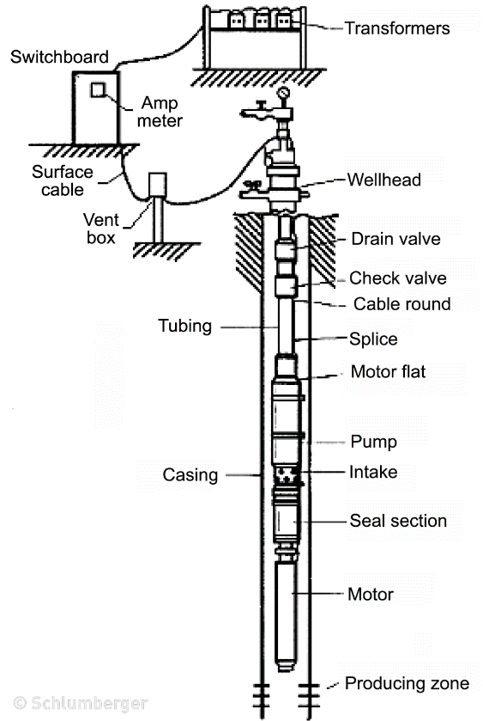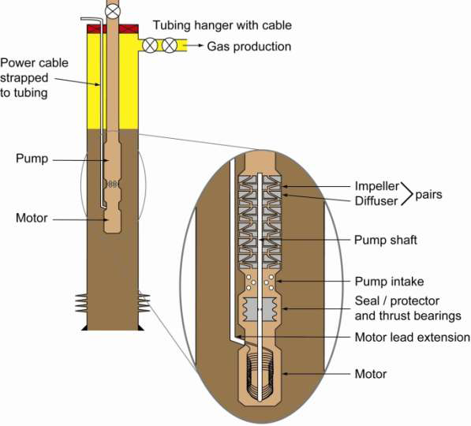
Fig. 2.1: Schematic Diagram of an ESP System (Schlumberger, 2001)
2.4.1 Electrical Submersible Pump
The pump used in an ESP is normally a multistage centrifugal pump. Each stage in the pump consists of one impeller and one diffuser, and the number of stages can exceed 200 (Vinge, 2012). The impellers are connected to the shaft, and runs at the same rpm as the motor. When the shaft and the impellers are spinning, centrifugal forces push the fluid from the middle of the impeller, the eye, and outwards to the edges. Unlike the impeller, the diffusers are stationary. When the pump is being assembled, impellers are diffusers are laid down in layers on the shaft. Radial impeller with pressure contours then put into a steel housing. Next they screw on a threaded base and head into the housing. The threaded head and base compresses against the outside edge of the diffusers, keeping them stationary. If the compression seizes, the diffusers would be free to rotate, and this rotation would cause the pump to lose almost all its lifting capability. There are two kinds of impeller, radial and mixed flow. Figure 3: Radial impeller with pressure contours shows how the pressure is distributed on a radial impeller. The fluid enters the impeller at the eye. The vanes on the impeller create channels where the fluid is directed. The fluid is accelerated from the center and towards the edge of the impeller, creating a low pressure zone in the middle of the impeller. This can be explained by Bernoulli’s principle. When the velocity increases, the pressure is reduced. The diffusers task is to direct the fluid from one impeller to the next one, and also convert a part of the kinetic energy, velocity energy, into potential energy, pressure (Lyons & Plisga, 2005).
2.4.2 ESP MOTOR
The submersible motor is called a prime mover. The motor is a two-pole, three-phase, squirrel-cage induction type, and it runs at a normal speed of 3500 RPM at 60HZ operation. The motor is filled with a highly refined mineral oil that has a specific gravity between 0.8 and o. 83. This feature makes sure that the motor has the required dielectric strength to prevent short circuits between motor parts, it gives proper lubrication for the bearing and it gives the good thermal conductivity required to carry the heart generated in the motor to the outside of the housing (Takacs, 2009). The thrust bearing is fixed-pad type, and its function is to support the thrust load of the motor rotors. The motor is cooled down by the well fluids when the fluids flow past the motor housing. Because of the required cooling effects needed in the motor, the ESP should not be placed at or below the well perforations. To provide enough cooling to the motor, a minimum fluid velocity of 1 ft/sec is recommended. The electricity needed to run the motor is led from surface via the power cable and to the motor. Because of the limited between the ESP and the inner casing diameter, a flat cable is used along the ESP. The motor is manufactured in four different diameters. 3.75, 4.56, 5,40 and 7.38 inches. The smallest diameter, 3.75 inches, make it possible to use ESP in casing sizes as small as 4.5 inches. The horsepower generated from these 60Hz motors range from 7.5HP for the 3.74 inch t0 1200 HP for the 7.38 inch motor (Lyons and Plisga, 2005). The electrical submersible pump motor differs greatly from other electric motors, due to their different working areas. These features are shown below.
- Since the motor is run inside the well’s casing string, the motors length to diameter ration is much greater than surface motors.
- The only way to increase the motor power of an ESP is to increase the length of the ESP.
- The surface motors are usually cooled by air, while the ESP is cooled by the surrounding fluids in the well.
- ESP Motors have low inertia and can accelerate to full speed in less than 0.2 seconds.
When selecting the motor to be used in an ESP setup, the first demand is that the ESP must be enough power, HP. Another limitation is the inner casing diameter of the well which determines how big the EP and the motor can be. When starting up an ESP motor for the first time, special consideration needs to be given to the operation. When the ESP is started there is an enormous instantaneous power requirement, because of the still-standing well fluid that is occupying the tubing string. As mentioned above the motor starts in a matter of seconds and because of the high power needed, the motor draws current several times higher than its rated current. As a result of the high current at startup, there will also be a big increase in the voltage drop across the electric cable, which means that the voltage that reaches the motor terminal is reduced. In order to ensure that the ESP can be started the general rule is that 50 percent of the voltage must be available at the motor terminals, which should be checked during startup (Takacs, 2009).
2.4.3. ESP Protector
The main task of the protector or seal section is to isolate the motor oil form the well fluid, while the bottom-hole pressure, BHP, and the motor’s internal pressure is balanced. In addition to the main task the protector has three other functions. The first is that the protector connects the pump to the motor by connecting both the housing and the drive shaft. The second is that it houses a thrust bearing to absorb pump shaft axial thrust, and the last function is that the protector allows for motor oil thermal expansion, which is resulting from operating heart rise and thermal contraction of the motor oil after shutdown (Lyons and Plisga, 2005). The three main components of a protector are the thrust bearing, the isolation chamber and the shaft seals. The thrust bearing in the pump absorbs some the forces from the high axial forces that are developed by the impellers in the pump. The thrust bearing the protector is responsible for eliminating the bulk of these forces. The thrust bearings that are most used is the pad-type plane thrust bearing, because they have advantages over bearings with rolling elements used in other applications.
- Less heat generation in the bearing during normal operation.
- Plane bearings can operate with lubricating oils containing solid particles.
- Plane bearings can support high thrust loads that bearings with rolling elements.
There are two types of isolation chambers in use in the industry today, and the main difference between the labyrinth- and the bag-type chambers is how they isolated the well fluids and the motor oil from each other. In the labyrinth-type chamber there is a direct contact between the motor oil and the ell fluids. The name labyrinth comes from the labyrinth path the motor oil takes due to contraction and expansion of the motor oil. The proper operation of such a chamber depends on the labyrinth path the motor oil take sand the difference in specific gravity between the motor oil and the well fluids. The bag-type chamber design consists of an elastic, fluid-barrier bag to allow for thermal expansion of the motor fluid in operate in, while isolating the well fluid form the motor oil. When the difference in the gravities of the motor oil and the well fluid is very small, the bag-type chamber can be used (Takacs, 2007) a shaft seal is a rotating mechanical seal that is installed on each isolation chamber of the protector. These seals prevent communication between the motor oil and the well fluids across the protector shaft. The seal contains a stationary seal ring fixed to the protectors housing and a rotating ring turning with the shafts movement. It is these parts that provide the dynamic seal and prevents migration along the rotating shaft (Takacs, 2009).
2.4.4. ESP GAS SEPARATOR
When free gas enters the pump section, the pumps performance is reduced. This is caused by the big difference in the specific gravities of liquids and gases. The existence of free gas at pump suction conditions, pressure and temperature affects the ESP pump in several ways.
- The head developed by the pump decreases
- When producing gassy fluids, cavitation can occur at higher flow rates causing
- Mechanical damages of the pump stages
- When producing with very high gas rates, gas locking may occur when no pumping is taking place.
The simplest and least efficient gas separator in use is often called a reverse flow gas separator. It uses the principle of gravitation separation by forcing the fluid flow to change director and allowing free gas to escape in the wells annulus. This separator can separate low to moderate amounts of gas with a limited effect. Another separator that is often used is the rotary gas separator. This separator works on the principle that is a multiphase mixture, if spun at a high speed in a vessel, is separated to its constituent liquid and gas phases due to the different levels of centrifugal force acting on the liquid and gas phases. The rotational speed is provided by the separators shaft and separation takes places within the separator (Takacs, 2009). The most efficient gas separator can handle up to 15 percent gas in the mixture (Vinge, 2012).
2.4.5 ESP CABLE
The electric power needed in the ESP motor is transmitted from the surface though a three phase electric power cable. Since the ESP cables work under extremely harsh conditions there are some important requirements they must meet:
- They must have small enough diameter to fit in the annulus along the well tubing.
- They must maintain their dielectric properties under harsh well conditions
- High temperature
- Aggressive fluid environment
- The presence of hydrocarbons and/or other gases
- They must be well protected against mechanical damage during running and pulling of the cable as well as normal operations.
The ESP cable is a very complex unit, with many features. The three metal conductors, usually copper, is carrying the AC, Alternating Current, while the individual insulation of each conductor prevents short circuits and leakage between the conductors, the jacked provides the structural strength and the mechanical protection of the cable. Choosing and designing the right cable can ensure the cable stays operational for many years.
2.4.6 Surface Equipment
The wellheads job is to maintain tubular control, as well as providing a positive seal around the cable and the tubing. There exist many different wellheads, with different features. The Hercules wellhead feeds the downhole power cable directly through the wellhead. In other wellheads, the power cable is cut and its end is equipped with a power connector (Takacs, 2009). The junction box is installed between the wellhead and the switchboard. Its main purpose is to connect the power cable from the well to the surface electric cable leading to the switchboard. The junction box, in addition to connecting the two cables, vents any gas to the atmosphere which might reach the junction box though migration of well gases up the ESP cable. This venting eliminates the danger of fire or explosion, since the gas does not reach the switchboard. It also possible the test the electric components downhole form the junction box (Takacs, 2009). The switchboard is the control center of a conventional ESP installation and functions as a motor controller. From the switchboard it is possible to control the on/off switching of the ESP equipment to the power supply using high capacity switch disconnectors. It also protects the surface and downhole equipment from any problems, in addition to monitoring and recording the most important operating parameters (Takacs, 2009).

2.4.7 Variable Speed Drive
The variable speed drive is, when used in ESP operations, installed between the power supply and the ESP motor, running a conventional ESP at a constant speed is not very flexible compared to other types of artificial lift. When operating an ESP pump outside of its narrow recommended operating window the systems efficiency will be reduced and also lead to early equipment failures. By installing a VSD, variable speed drive, it is possible to change electric frequency. If the pump is driven by a 600 hertz power supply and its recommended range is between 2.400 and 4.600 barrels per day, it is possible by regulating the frequency from 40 to 70 hertz to get a much wider range of flow rates, approximately from 1.600 to 5.400 barrels per day.
To regulate the frequency, there is installed a step-down transformer between the power supply and the VSD and a step-up transformer between the VSD and the ESP motor.
2.5 THROUGH-TUBING ESP
Conoco Philips Alaska developed the Through-Tubing Conveyed Electrical Submersible Pump (TTCESP), technology in order to replace failed ESP pumps rapidly and economically, because conventional ESPs require expensive workover rigs to replace the component that fails most frequently, the ESP pump. In the newly developed system, the system components, electrical cable, motor and seal sections, was deployed conventionally by a rig. In addition they deployed a special latching device for the pump. The pump can then be pulled and replaced with wire line or coiled tubing and it eliminates the requirements of a rig. The technology was originally developed to be used for 7 5/8 inch cased wells, and it was believed that it could not be used at Milne Point field in Alaska, because the here the wells were smaller, 7 inches. At the Milne Point Field there are 152 oil producers, where 104 wells were smaller, 7 inches. At the Milne point field there are 152 oil producers, where 104 wells have an ESP installed. Even though ESPs provide high drawdown and increased production, there are also some major disadvantages. Low solids tolerance, limited reservoir access and the most important disadvantage is that is one component fails the whole unit must be replaced. At Milne Point the ESPs were replaced out approximately every 3.5 years. The reason why they wanted to use TTCESP at this point was mainly to reduce operational costs, because of high rig costs, limited rig availability and declining oil rates. The first step they took was to analyze the historical causes for rig workovers, RWOs. In the analysis it was shown that pump- related RWO accounted for 50.85%, while well-related RWOs accounted for 23.73% which were the two biggest problems. The analysis also showed that reducing the cost of pump changes would have the biggest impact on operations costs, compared to increasing the pump life. They then started to evaluate alternative methods of ESP deployment, such as coiled-tubing deployed ESPs, dual ESPs, cable-deployed ESPs and TTCESPs. Initially they thought that the easiest solution would be to use coiled-buging deployed ESPs, since they at Milne Point already had over 400 coiled-tubbing interventions per year. But since they had experienced corrosion problems with earlier CT. coiled-bubing, deployed ESPs they chose to use TTCESPs. With the TTCESP they could change the pump as many times as necessary until the integrity of the tubing-deployed components were compromised. The next phase was to check if Milne Point had enough TTC – candidates, in order to find out whether or not they should develop the TTC technology for the 7 inch completions. Earlier the TTC- technology had only been used on 7 5/8 inch completions. The ideal candidates would be wells that produced between 600 and 6000 barrel per day with low deviation in the well and no severe doglegs. They found 91 candidates of a possible 130 ESP wells they specially designed low-clearance clamps to fit on the ESP pump, in order to downsize the TTC- technology fit smaller completions. In November 2009 the first TTCESP was deployed in Milne Point, which was the world’s deepest TTCESP run at the time. Only a few months later, they deployed another TTCESP in the Kuparak Field which almost doubled the world depth record. The modifications they needed to do in order to deploy the completion inside the 7 inch casing included a short well head spoolpiece, low profile clamps and modified RWO procedures. The TTC pumps they used at Milne Point Field can easily be up-sized or downsized to optimize for production rate changes. After the successful deployments, all ESP-lifted wells at Milne point are now being considered for TTCESP technology when they have an ESP failure. As of 3 March 2011, the first well has 68 days’ run time and the second well has 245 days’ rune time (Julian, 2011).

2.6 ESP PERFORMANCE ON THE OLOIBIRI FIELD
The oloibiri field is an onshore oilfield located in Oloibiri in Ogbia Local Government Area of Bayelsa State, Nigeria, about 45 miles (72km) east of Port Harcourt in the Niger Delta. Oloibiri field is about 13.75 square kilometers (5.31m²) and lies in a swamp within OML 29. The field started oil production between late 1957 and early 1958 and the first oil production from the field came at the rate of 4928 barrels per day (783.5m³/d). Some of the wells experienced a rapid decline and artificial lift method became necessary. The ESP was selected as the most suitable recovery methods, because other artificial lift methods would require more space for facilities. In addition to that, oil production with high water-cut was inevitable and higher lifting capacity was required, all the reservoirs in the Oloibiri Field are under saturated and contain low solution Gas-Oil Ration (GOR). The only disadvantage of using ESPs was higher operation costs due to workover jobs because of ESP failures. Since they started using ESP in the Oloibiri Field, they have logged, monitored, investigated and improved the ESP they have used. For the pumps, intake gas separators, protectors and motors they have found solution on how to improve the lifetime of the components and how to prevent failures. The pump they chose was a floater-type pump because the impellers material was a thermoplastic component called Ryton. They chose these Ryton impellers since they give dimensional stability against high temperature, chemical stability, corrosion resistance and they weighed less. The corrosion environment for the ESPs in the Oloibiri field is very severe; the Ryton impellers were more suitable then conventional corrosion resistant metal.
Another factor in the pump is the shaft stability. If the shaft were to vibrate n either radial or vertical direction, it could cause major ESP failure, and thus diminish the ESP lifetime. The team at Oloibiri field chose to go with the ES-pump, Enhanced Stability, which uses ARZ shaft bearings. The ARZ shaft bearings main parts are solid zirconia ceramic bearing Paris, and was chosen because of its high strength shaft which is high corrosion resistant and gives high strength for high torque. For the gas separators the team chose reverse flow type, because of the corrosive environment on the Oloibir field. Both the intake and the gas separator was ARZ in order to increase the reliability of shaft stabilization. The high thrust bearings were chosen for the protectors, because they can withstand high load and high temperatures, maximum 300 degrees Fahrenheit. The thrust bearing also include a tilting pad system made of Hi-ex polymer to increase the reliability of the thrust bearing. For the seal section, they had two choices, bag-type or labyrinth-type. They chose to use the labyrinth-type seal, because the bag type could not be applied in the high pressure and high temperature environment on the Oloibiri field. Since the motor in an ESP cannot be maintained after installation in the well, the reliability of motors is very important and can be a big impact on ESP lifetime. They decided to use a new insulation system.
The used Advanced Insulation System (AIS, which uses polyetheretherkepton (PEEK), insulation without varnish. The AIS is hydraulically stable, oil-resistant and abrasion resistant and its lifetime is expected to be more than 7 times longer than the previous insulation system used on the Oloibiri Field. After all the improvements that were done on the ESPs the average lifetime went from 2:12 years to over three years.
The current problems to be solved are ESP failure due to well conditions. Detailed inspections of the ESPs after a failure are significantly effective to prevent future ESP failures (Masahiro Miwa, 2000).

2.7 SELECTING THE SUCKER-ROD PUMPING METHOD
Many factors must be considered when determining the most appropriate lift system for a particular well. Artificial lift selection methods present a discussion of the normally available artificial-lift techniques, their advantages and disadvantages, and the selection of a method for a well installation (Clegg, 1988) and (Hein, 1996). Sucker-rod pumping systems should be considered for new, lower volume stripper wells, because they have proved to be cost effective over time. Operating personnel usually are familiar with these mechanically simple systems and can operate them efficiently. Inexperienced personnel also can operate rod pumps more effectively than other types of artificial lift. Most of these systems have a high salvage value.
Because of its long history of successfully lifting well fluids, the sucker-rod lift method is normally considered the first choice for most onshore, and even some offshore, installations all over the world. This method is limited by:
- Size of the casing, tubing, and downhole pump
- Strength and size of the various rods
- Speed with which they can be reciprocated under favorable conditions, approximately 150 BFPD can be lifted from greater than 14,000 ft, while more than 3,000 BFPD can be lifted from less than 2,000 ft.

2.8 UNDERSTANDING THE RESERVOIR FOR SUCKER SELECTION
Understanding the makeup of the producing reservoir, its pressure, and the changes that occur in it are important to attain maximum production. Because reservoir conditions change as fluids are produced, ongoing measurement of the reservoir conditions is necessary. The main considerations in measuring and understanding the reservoir are the types and volumes of reservoir fluids being produced, their pressures in both the reservoir and at the wellbore or pump intake, and the effects these fluids have as they pass through the producing system.
2.9 DESIGN GUIDANCE
Gipson and Swaim (1988) did an excellent job of summarizing a sucker-rod lift-system design in The Beam Pump Design Chain with the API RP 11L approach. This recommended practice should be consulted for continued discussion of this equipment, along with a review of a sample problem and a recommended solution. In summary, use the design procedure presented in API RP 11L or a suitable wave equation. Several commercial wave-equation computer programs are available that many operators have successfully.

2.9.1 Gas production
In any artificial lift system, the volume of gas produced should be considered in designing the system and in analyzing the operation after the system has been installed (Donnelly, 1986). A complete analysis requires knowing the volume of gas in solution, the volume of free gas, the formation volume factors, and whether gas is produced through the pump or is vented. If PVT analyses of reservoir fluids are available, they are the most accurate and easiest to use as a source of solution gas/oil ratio (GOR), formation volume factors, etc. The next best source is an analysis from a nearby similar reservoir.
A means of estimating PVT data is contained in Volumetric and Phase Behavior of Oil Field Hydrocarbon Systems. Standing (1952), with the produced GOR, gas gravity, oil gravity, and reservoir temperature, the following can be estimated using chart.

2.9.2 Inflow performance relationship (IPR)
One of the most critical decisions in an artificial-lift system is the selection and design of equipment appropriate for the volume of fluid the reservoir produces. Reservoir inflow performance details, the productivity index and IPR of fluids with changes in reservoir pressure are basic parameters. Because most fluid produced by an artificial lift method is not single phase, it is not in a steady-state condition. Also, because most pumping operations occur after the fluid is below the bubblepoint pressure, the IPR method is usually considered. This technique takes into account various fluid phases and flow rates. It was originally devised by Vogel (1968) and described by Eickmeier (1968). Each revision increased the accuracy of estimating flow rates from a well.
In the design of an artificial lift system, it is necessary not only to predict production of the various fluids during existing conditions and reservoir pressure, but also to make a second type of prediction: future pressure performance. This can be accomplished with the IPR method and multiple, or a family of, IPR curves. Furthermore, the family of curves can be used to predict estimates of fluid production increases if the reservoir is repressurized from waterflooding or other secondary or tertiary methods.
Producing rates can be estimated within the desired range of accuracy using the IPR technique with two stabilized producing rates and corresponding stabilized producing pressures. This makes it possible to use the IPR without needing to shut in the well and lose production to obtain shut-in information. Obtaining a bottomhole pressure equal to 10% of the shut-in reservoir pressure is recommended for determining maximum production rates for sucker-rod lifted wells. At this pressure, the maximum well productivity will be 97% of the well's theoretical maximum production rate. However, the maximum lift-design rate should, in most cases, be slightly higher to permit some downtime and decreased pump efficiency.

CHAPTER THREE
METHODOLGY
3.1 Material and Data Requirement
The following set of data variables and material were employed in this research:
- Production Survey Data: (Bottom hole flowing pressures at tested point (Pwf), wellhead Pressure at tested point (Pwh) and flowing production rate (q).
(2) PVT Data: (Gas oil ratio (GOR), API gravity, water cut and viscosity).
(3) Reservoir Data: (Reservoir Pressure (Pr), Reservoir Permeability (K) and skin value (s).
(4) Proper 11.5 software.
3.2 HISTORY OF THE STUDY OILFIELD
The case study field is an onshore exploratory field located in the creek area of Niger Delta, Nigeria. The field was spudded on the 20th of August 2004. The API gravity ranges from 19-30 degrees. The field production development empties into a central production platform. The velocity is 1.634ft/sec with a high GOR and water cut experienced after four years of production. The reservoir porosity ranges from 25-38% with an initial pressure 0f 4000psi. Production began at a low rate due to the early water cut encountered at the initial commencement production. The future development is to increase production from 20% to 45% of the present production rate using artificial lift method.
3.3 METHOD
To address the low production issue facing the case study field, the performance relationship analytical approach was adopted in this project. The current production data variable and the PVT data of Apo well located in the field is used to model the present condition of the field.
The considerations for the modelling on prosper were; the natural flow of the well, the flow under electrical submersible pump and the flow under sucker rod pump.
The ESP and sucker rod design variable were that of a nearby field to the case study field. Darcy flow model was used in the inflow performance to account for the water cut. Here, the operating point of the well was determined by the inflow and outflow curves intersection point for the two artificial lift under consideration.
3.4 PROCEDURE
The procedure adopted in this research is grouped into two categories; the first category involves the gathering of data. Here, through the permission of the Department of Petroleum Resources (DPR), production data and history of the case studied oil well was obtained and treated to suite its use for modelling of the present state of the well. Prosper Petroleum Software was used to model the treated data after successful studying of the software for its suitability as a tool in handling the problem.
The second category involves simulation, this process started by defining the black oil properties variable of the oil phase of the well, followed by inputting the PVT data and the inflow data variables on the software. To define the present condition of the well, the well performance relationship curves were simulated for the complete system (inflow and outflow curves) to determine the operation point of the well. In designing for well improvement, the following assumptions were made for both the artificial lift methods used in this research:
- The design parameters used for both artificial lift methods remain constant.
- The liquid level at the tubing was 5000 ft.
- Darcy flow correlation was considered for both methods.
The both systems were designed to kick start at the production rate of 200stb/d at the depth of 7000ft, but on simulation; the sucker rod design was limited to the design depth of 5900ft.

CHAPTER FOUR
RESULTS AND DISCUSSION
4.1 RESULTS:
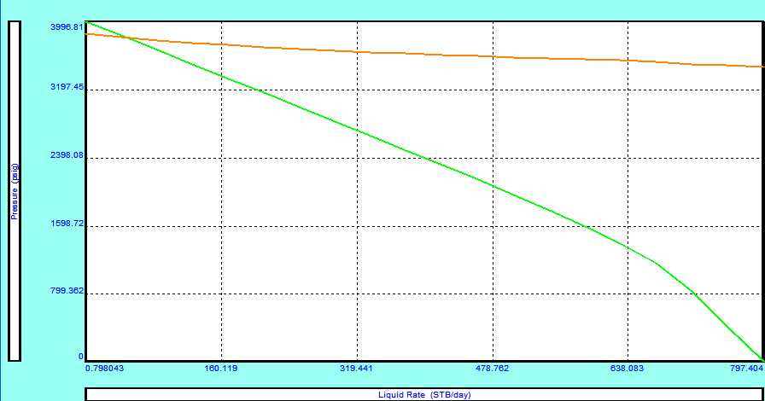
Fig.4.1: IPR Curve of APO Well on Natural Flow
Figure 4.1 is the IPR curve of APO well on natural flow. This result was obtained by simulating the APO oil field data variable in its natural flow state on prosper to determine the operating point (OP) of the well, the absolute open flow (AOF) of the well, the liquid and oil flow rates.
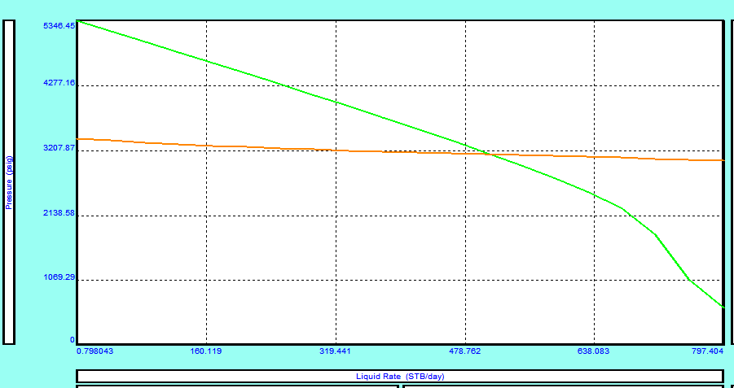
Fig.4.2: IPR Curve of APO Well on ESP Flow
Figure 4.2 is the IPR curve of APO well on ESP flow artificial lift system. This result was obtained by simulating an incorporating ESP system design to the natural state data variable of the APO well on prosper to determine the operating point (OP) of the well, the absolute open flow (AOF) of the well, the liquid and oil flow rates.
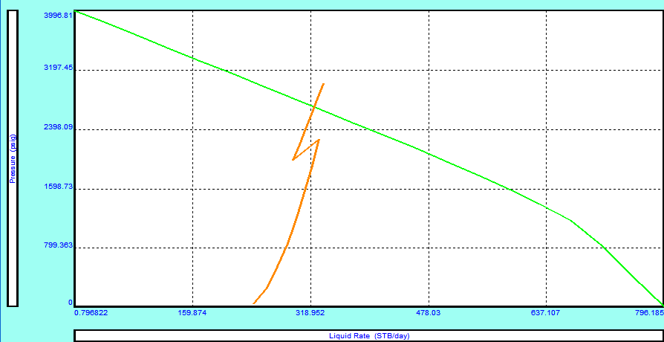
Fig.4.3: IPR Curve of APO Well on Sucker rod Flow
Figure 4.3 is the IPR curve of APO well on Sucker rod flow artificial lift system. This result was obtained by simulating an incorporating Sucker rod system design to the natural state data variable of the APO well on prosper to determine the operating point (OP) of the well, the absolute open flow (AOF) of the well, the liquid and oil flow rates.
Table.4.1: APO oil well simulation summary
Flow system | Simulated liquid rates (stb/d) | Simulated oil rates (stb/d) | Simulated drawdown (psi)
Natural | 48.8 | 9.3 | 163.044
ESP | 609.9 | 90.9 | 578.273
Sucker rod | 329.8 | 62.5 | 1,202.219

4.2 DISCUSSION
The discussion in this project is based on the parameters used for consideration of well performance from a quick point of view. These are; the liquid and oil flow rates at the operating point of the well, the absolute open flow (AOF) and the pressure draw down at the operating point. The absolute open flow (AOF) defines the well’s potential to flow in the absent of formation damage and less pressure drop in the various segment that caused pressure lost during production. Figures 4.1, 4.2 and 4.3 show the AOF of 797.404 stb/d for the natural flow and the two artificial lift methods compared respectively. These indicate that APO well has the potential to produce liquid at the rate of 797.404 stb/d at 0psi or near 0psi. Since production is against pressure drop, the AOF production could not be achieved practically, but it serves as a potential point to show that effective management of the APO well reservoir and well pressure could lead to the achievement of production near AOF.
The operating point is the intersection point for the inflow curve (i.e. flow from the reservoir to the wellbore) and outflow curve (i.e. Flow from the wellbore to the surface). This point defines well performance in terms of rate and the corresponding wellbore draw-down pressure. Figure 4.1 show that APO well on natural flow has a very low operating point with the liquid and oil rates of 48.8stl/d and 9.3 stb/d at the pressure drawdown of 163.044 psi respectively. These values indicate that APO well is performing very low. The low performance is caused by a number of factors, but in this project, consideration is given to water cut as reflected in the simulation summary. To arrest this issue, the performance curves of the two designed artificial lift were compared to check for improvement in the liquid/oil flow rate over the natural flow rate. Figure 4.2 show the ESP well performance curve of APO well. The curve indicates liquid flow rate of 609.9 stb/d and the simulated oil rate of 90.9 stb/d at the operating point. Similarly, the sucker-rod performance curve indicates liquid flow rates of 328.8stb/d and the simulated oil rate of 62.5stb/d (figure 4.4).
From these results, ESP performs better compare to sucker rod. The compared variables in table 4.1 further show that ESP has a more significant performance over sucker rod, ESP will increase the economic viability of the well over it natural flow. Again, from the reservoir management perspective, ESP will contribute to a more effective pressure utilization to aid flow to the wellbore. From figure 4.3, it could also be seen that sucker rod performance is equally limited by high gas oil ratio (GOR) as indicated in the distorted nature of the outflow curve.

CHAPTER FIVE
5.0 CONCLUSION AND RECOMMENDATION
5.1 CONCLUSION
For better decisions in the selection of artificial life for wells whose oil production has decline due to multiphase flow from the reservoir, there is need for a quick review and iteration using the reservoir and the well production data as adopted in this project. The well performance approach was adopted as tool box for a quick check in this regard. A comprehensive work has been done in the review of the two compared artificial lift methods. To justify their need for assisting the flow of oil to the surface, APO well production data were used for the design of artificial lift simulation to determine the well performance at natural flow, sucker rod flow and ESP flow. The results obtained and the lessons learnt are highlighted as follows:
- Sucker rod system is limited by well depth
- Sucker rod system is not suitable for well with very high GOR
- ESP system has depth advantage over sucker rod.
- APO well on natural flowing has the liquid flow rate of 48.8stb/d and oil flow rate of 9.3stb/d (Figure 4.1).
- APO well on sucker rod flow has the liquid flow rate of 329.8stb/d and oil flow rate of 62.5 stb/d (Figure 4.3).
- APO well on ESP flow has the liquid flow rate of 609.9stb/d and the oil flow rate of 90.9stb/d (Figure 4.2)
- At a very high GOR, there is unstable flow of oil from the wellbore to the surface on a sucker rod flow system (Figure 4.3)
5.2 RECOMMENDATION
To curtail early production decline in oil wells, there is need for proper surveillance of the well performance with the used of production data and other engineering indices. In this project, the sucker rod system suffered some set back in the comparative study; these are well depth and high GOR in the production column of the well. This project is open to other comparative approach for effective selection of the right artificial life method on the event of failure of natural flow energy.

REFERENCES
Bailie, A. (2002). Optimizing ESP Run life. A Practical Checklist. Paper Presented at the 2002 European ESP Roundtable, Aberdeen, 6, February.
Breit, S. and Neil Ferrier, W. G (2008). Pump –Zone .com. Retrieved January 28, 2012 from http:// www.pump-zone .com /topics /pumps/electric submersible Pumps–Oil and Gas Industry.
Brown Kermit E. (1982). overview of Artificial Lift System, pp. 20-25
Clegg, J. D. (1988). High-Rate Artificial-Lift. J Pet Technology 40 (3): 277–282. SPE-17638-PA. http://dx.doi.org/10.2118/17638-PA
Donnelly, R. W. (1986). Oil and Gas Production: Beam Pumping. Dallas, Texas: PETEX, University of Texas.
Duran Javier and Prado Mauricio (2003). ESP Stages Air-water two–phase Performance Modeling and Experimental Data
Eickmeier, J. R. (1968), How to Accurately Predict Future Well Productivities.
Gipson, F. W. and Swaim, H. W. (1988). The Beam Pumping Design Chain. Paper presented at the 1988 Southwestern Petroleum Short Course, Lubbock, Texas, 23–25 April.
Hein Jr., N.W. (1996). Beam-Pumping Operations: Problem Solving and Technology Advancements. J Pet Technology 48 (4): 330-336. SPE-36163-MS. http://dx.doi.org/10.2118/36163-MS
Heinze Lioyd R. and Herald W. Winkler (1995). Decision Tree for Selection of Artificial Lift Method.
Julian J. Y, J.B (2011). World’s Deepest Through Tubing Electrical Submersible Pump SPE
Lea F. James and Bearden J.L (1982). Effect of Gaseous Fluid on Submersible Pump Performance.
Lyons, W. and Plisga, G. (2005). Production Engineering, Standard Handbook of Petroleum and Natural Gas Engineering pp. 6-188
Masaniro Miwa, Y. T (2000). ESP Performance in Oloibiri Field SPE
Pessoa Rui and Prado Mauricio (2003). Two-phase Flow Performance for Electrical Submersible Pump Stages’ SPE.
Powers Maston L (1987). Effects of Speed Variation on the Performance and Longetivity of Electrical Submersible Pumps.
Sachdeva Rajesh, Doty D. R. and Zelimir Schmidt (1992). Performance of Axial Electrical Submersible Pumps in a Gassy Well.
Standing, M. B. (1952). Volumetric and Phase Behavior of Oil Field Hydrocarbon Systems. New York City: Reinhold Publishing Corp.
Takacs, G. (2009), ESP Components and their Operational Features, Manual Design. Pp. 51-117
Takacs, G. Szilas, A. P. and Sakharov, V. A (1984). Hydraulic Analysis of Producing Wells, pp. 36-129.
Vachon G. and Furui K. (2005). Baker Oil Tools; “Production Optimization in ESP Completions with Intelligent Well Technology by Using Downhole Chokes to Optimize ESp Performance”
Vogel, J. V. (1968). Inflow Performance Relationships for Solution-Gas Drive Wells. J Pet Technology 20 (1): 83–92. SPE 1476-PA. http://dx.doi.org/10.2118/1476-PA
Wilson B. L. (1994). ESP Gas Separator’s Effect on Run Lift, pp.20
Wilson B. L., Mack John, Centrilift, and Foster Dannny (1998). AMOCO Production Company. “Operating Electrical Submersible Pumps Below The Perforations”
www.pump-zone .com/topics/pumps/electric-submersible-pumps-oil-and-gas-industry
Zaba, J. (1943). Oil Well Pumping Methods: A Reference Manual for Production Men. Oil and Gas J. (July).
Zaba, J. (1962). Modern Oil Well Pumping. Tulsa, Oklahoma: Petroleum Publishing Co.

Pwf at tested point  Pwh at tested point  Skin  Q(s) at tested point  GOR  API  Water Cut  Reservoir Permeability (k)  Reservoir pressure (Pr)  TVD | 215 psig  250 psig  +3  48.8 (stb/d)  588  30  74%-87% (81.0%)  150 md  4000 psig  7000ft
APPENDICES

Darcy Fluid Model:
Q = (kA/µ) * (dp/dx)
Q = flowrate of the formation (in units of volume per unit time)
k = permeability of the formation (in millidarcys)
A = cross-sectional area of the formation
μ = viscosity of the fluid (typically in units of centipoise)
∂p/∂x = the pressure change per unit length of the formation.

